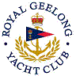 | Royal Geelong Yacht Club Inc.  Est 1859
Trophy Deed of Gift.

Trophy: | Committee Trophy
Presented by:
Date:
For: | Event So Named
Remarks / Revisions | Not in Cabinet

